Go to Single User mode
Hold down the left Shift key while rebooting to bring up GRUB menu
- Select (highlight) the GRUB boot menu entry you wish to use.
- Press e to edit the GRUB boot commands for the selected boot menu entry.
- Look near the bottom of the list of commands for lines similar to
linux /boot/vmlinuz-3.2.0-24-generic root=UUID=bc6f8146-1523-46a6-8b\
6a-64b819ccf2b7 ro quiet splash
initrd /boot/initrd.img-3.2.0-24-generic
- Change the middle line in (4) by adding the kernel boot parameter single to the end of the line (i.e. after ro quiet splash).
For this example you would change:
6a-64b819ccf2b7 ro quiet splash
to
6a-64b819ccf2b7 ro quiet splash single
- Press either Ctrl+X or F10 to boot using these kernel options.
OR

Occasionally, you might not be able to use the single method as described in the accepted answer. In those cases you can tell the Linux kernel to use a different init like so:
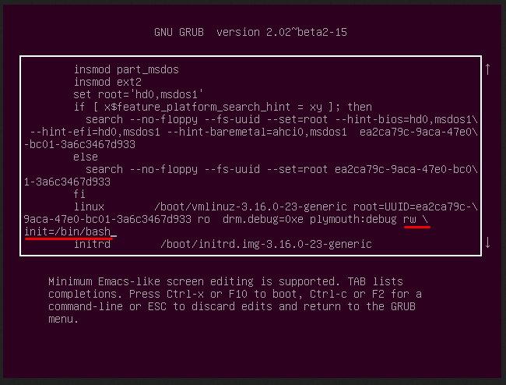
init=/bin/bash

